### **💡 Machine Learning Definition**

Machine Learning is a field of AI that enables computers to learn from data **without being explicitly programmed**.

### **📘 Supervised Learning Explained**

Supervised learning is a type of ML where the model learns from **labeled data**.  
 Each training example includes an **input** and the correct **output** (label), and the model learns to map inputs to outputs.

**Example:**

* Input: "This is spam"
* Output (label): Spam
* Goal: Learn to classify new emails as spam or not spam.

## **🔵 Regression (Predicting a number)**

**Definition:** Regression is a type of supervised learning where the goal is to **predict a continuous value** (a number).

### **📊 Example (from the image):**

**Problem:** Predicting house price based on its size.

* **Input (X):** House size in square feet
* **Output (Y):** Price in $1000s
* e.g., A house of size **750 ft²** → Predict price (say, **$150K or $200K**)

### **🔍 Visual Understanding:**

* Red crosses = actual data points
* Blue curves = prediction models
* The model learns the pattern to estimate price for any given size.

### **➕ Real-world Regression Examples:**

* Predicting temperature tomorrow
* Estimating someone's weight based on height
* Predicting exam scores based on study hours

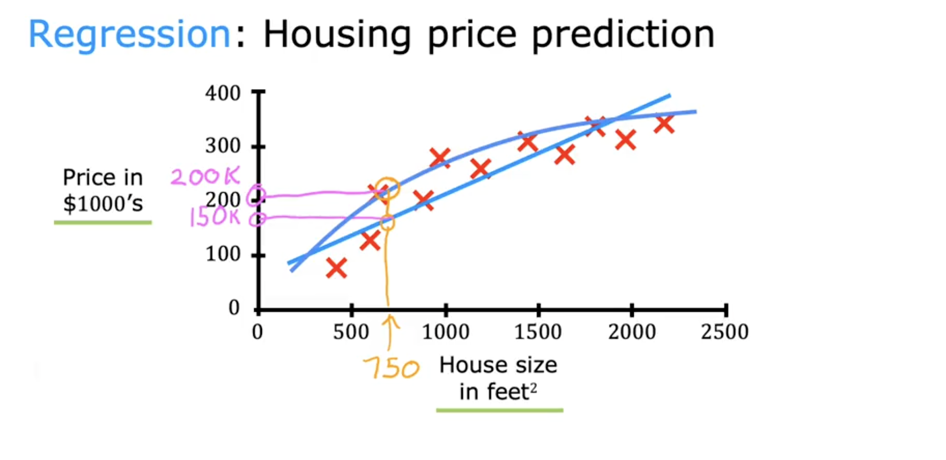

## **🟣 Classification (Predicting a category)**

**Definition:** Classification is a type of supervised learning where the goal is to **predict a discrete label/class**, like categories (0, 1, 2...).

### **🎗 Example: Breast Cancer Prediction**

**Problem:** Predict whether a tumor is malignant or benign.

* **Input (X):** Tumor size, shape, etc. (e.g., horizontal size)
* **Output (Y):**
  + 0 → Benign (non-cancerous)
  + 1 → Malignant (cancerous)
* You never predict 0.5 or 0.75, only **finite classes**.

### **➕ Real-world Classification Examples:**

* Email: spam or not spam
* Self-driving car: identify pedestrian, car, traffic light
* Speech recognition: classify spoken word
* Visual inspection: defect or no defect in factory line

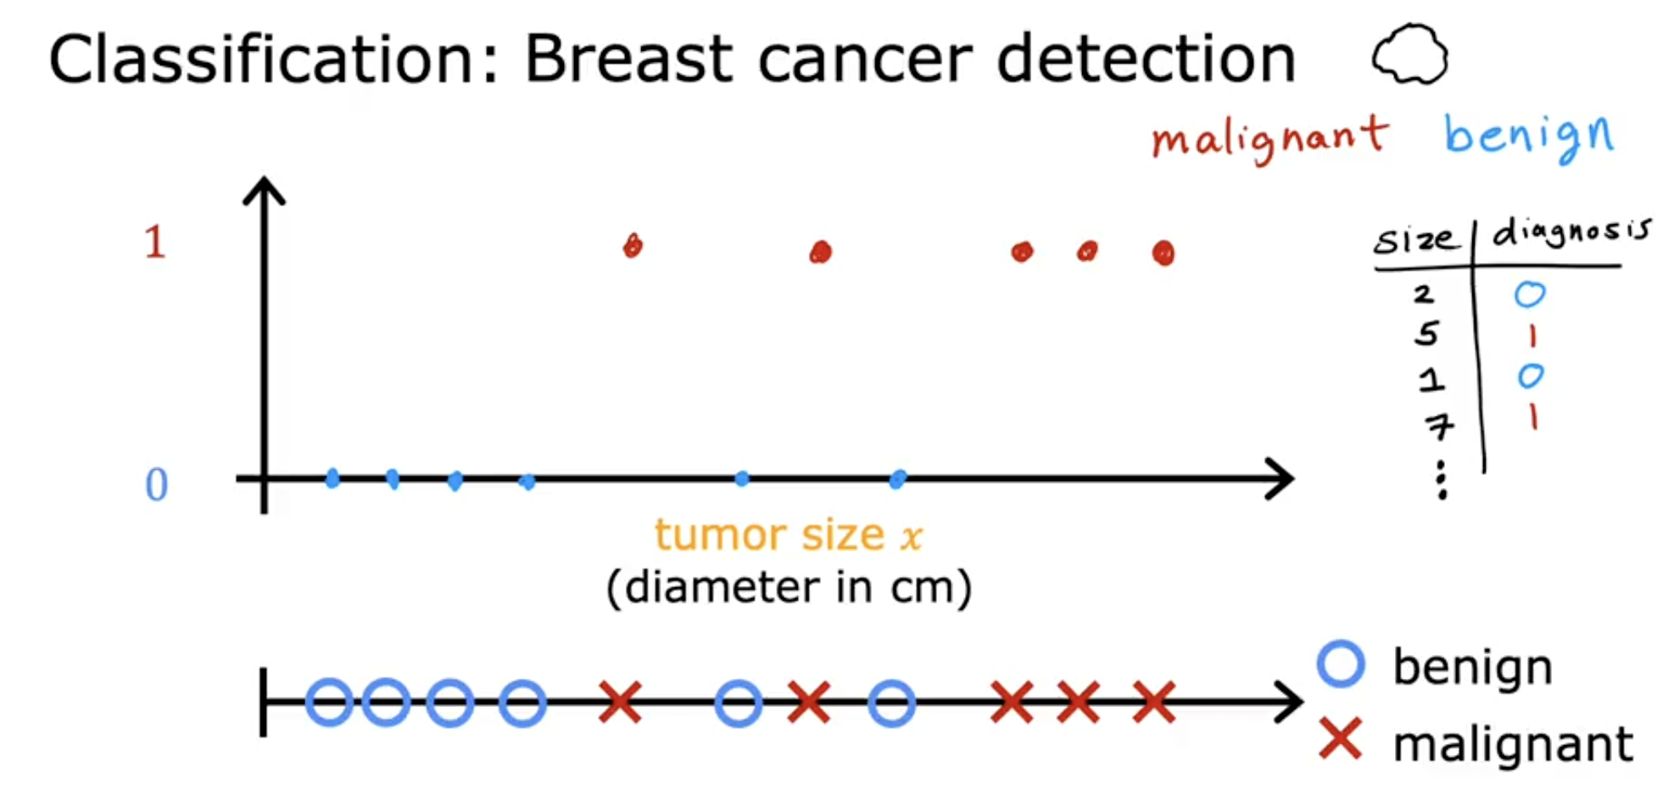

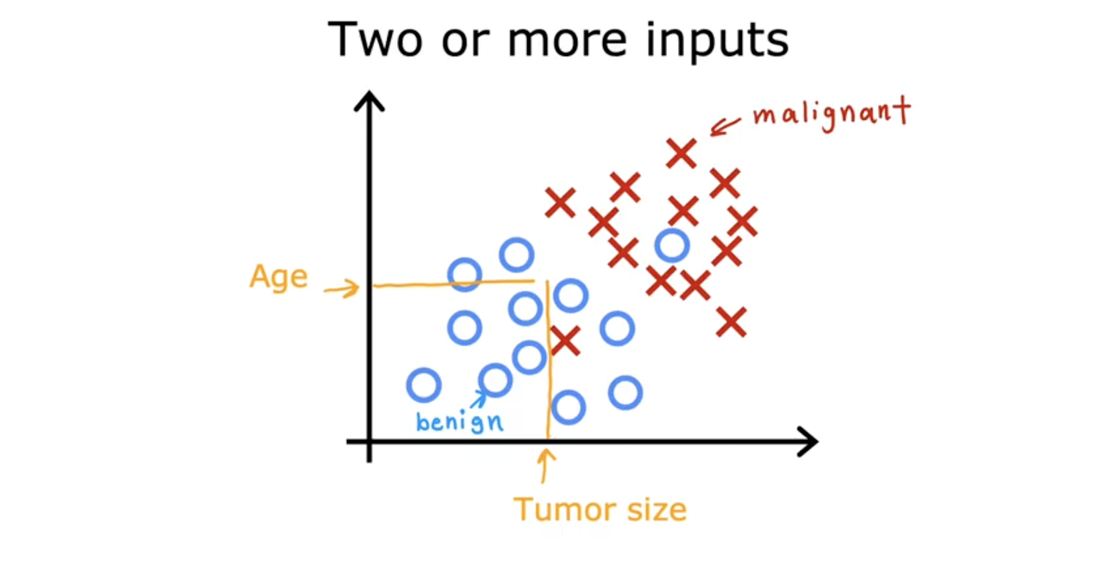

## **🔁 Difference: Regression vs Classification**

| **Feature** | **Regression** | **Classification** |
| --- | --- | --- |
| Output type | Continuous number (e.g., 123.45) | Discrete class (e.g., 0, 1, or 2) |
| Example | House price prediction | Tumor type prediction |
| Prediction value | Any number (e.g., 150.5K) | Limited labels (e.g., 0 or 1) |
| Common algorithms | Linear Regression, SVR | Logistic Regression, Decision Trees |
| Visualization | Line/curve fit through data points | Class boundary separation |

### **🟡 Unsupervised Learning**

**Definition:** Unsupervised learning is a type of machine learning where the algorithm is given **only input data (X)** and **no labeled outputs (Y)**.  
 The algorithm tries to **find patterns, groupings, or structure** in the data **without supervision**.

## **🔹 Key Concepts in Unsupervised Learning**

### **✅ 1. Clustering → *Grouping similar data points together***

### **Example 1: Google News Article Clustering**

* Articles about **"pandas"** and **"zoos"** appear in 5 different news pieces.
* The algorithm **detects similarities** in keywords and **groups** them into a cluster about wildlife or animals.
* No human labels are given – it **figures it out on its own**.

📌 **Use case:** Google News automatically groups similar stories under one headline.

### **Example 2: DNA, Eye Color, Height**

* Input data: genetic features like DNA, eye color, height, etc.
* The algorithm **groups people** based on these traits.
* It may discover **"Type 1"** humans who have similar genetic traits, **without knowing beforehand** what those types are.

📌 **Use case:** Genetic research, personalized medicine.

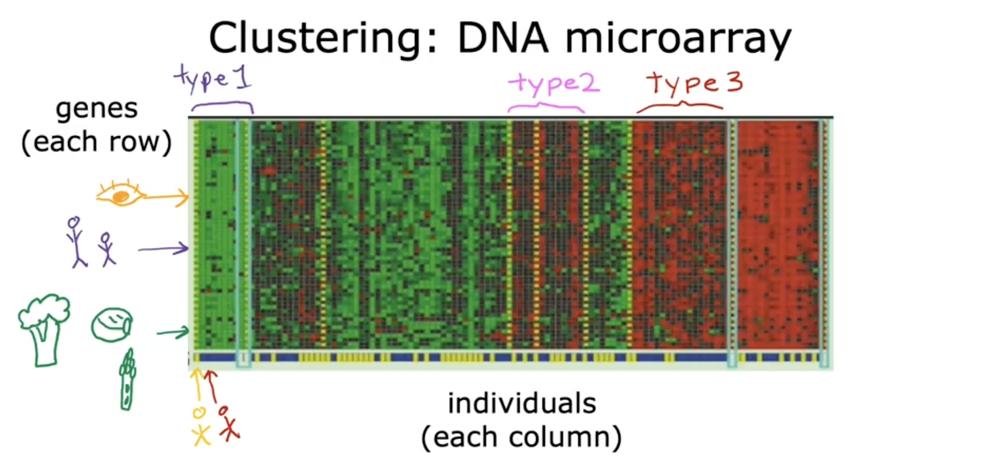

### **Example 3: Customer Segmentation in Marketing**

* Input data: customer behavior like purchase history, time spent, age, income.
* The algorithm groups customers into **different market segments** like:  
  + Type A: wants to grow skills
  + Type B: wants to earn money
  + Type C: stays updated
* This helps businesses **target each group separately**.

📌 **Use case:** Amazon or Netflix personalizing recommendations.

### **🧠 No Labels (Y):**

Just raw data (X).

Model learns **structure** or **hidden patterns** on its own.

## **🔸 Other Unsupervised Techniques**

### **🔍 Anomaly Detection**

* Find rare or unusual data points (outliers)
* Example: Detecting credit card fraud or server attacks

### **📉 Dimensionality Reduction**

* Reduce large number of features to few important ones
* Helps visualize high-dimensional data
* Techniques: PCA (Principal Component Analysis), t-SNE

## **📌 Summary Table**

| **Feature** | **Unsupervised Learning** |
| --- | --- |
| Labels provided? | ❌ No (only input X) |
| Goal | Find hidden patterns/structures |
| Key techniques | Clustering, Anomaly Detection, PCA |
| Common algorithms | K-Means, DBSCAN, PCA |
| Real-world examples | News grouping, DNA clustering, Market segmentation |

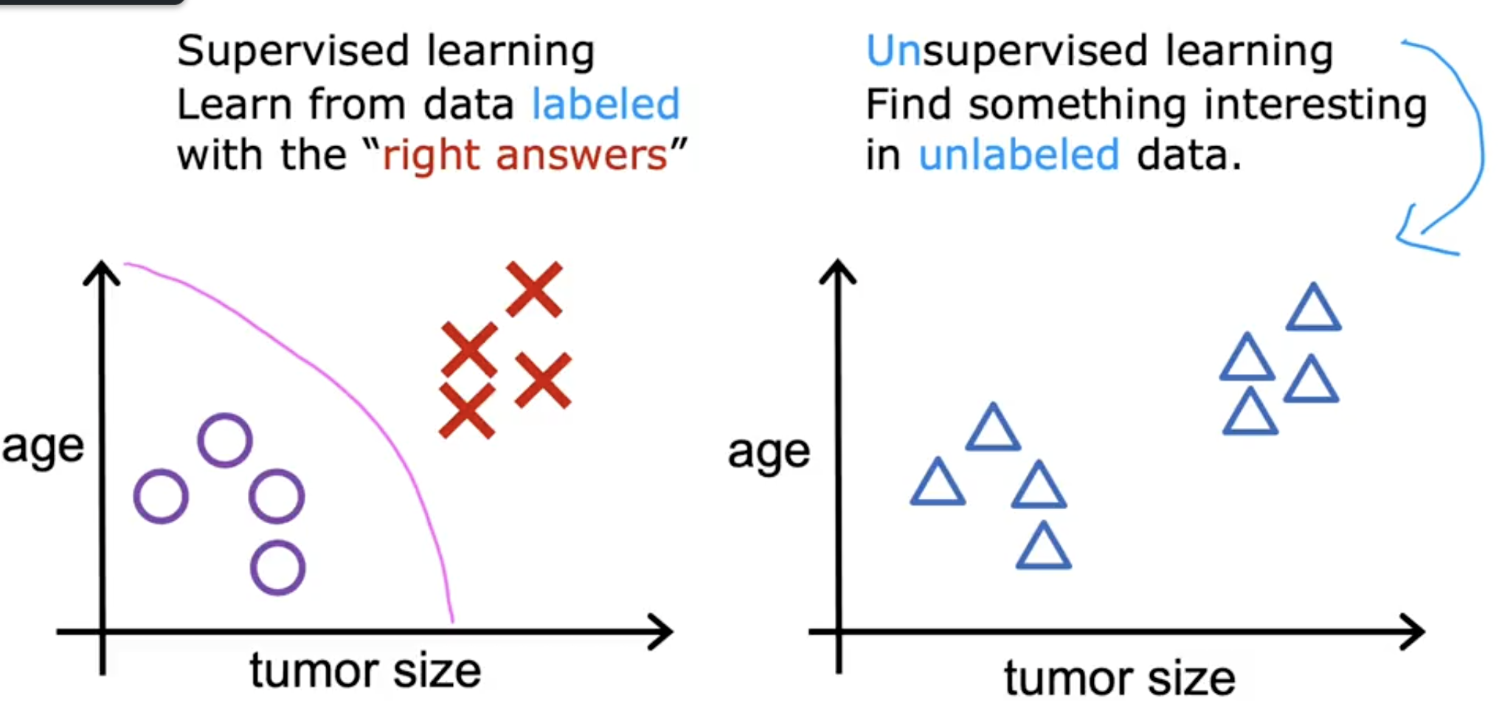

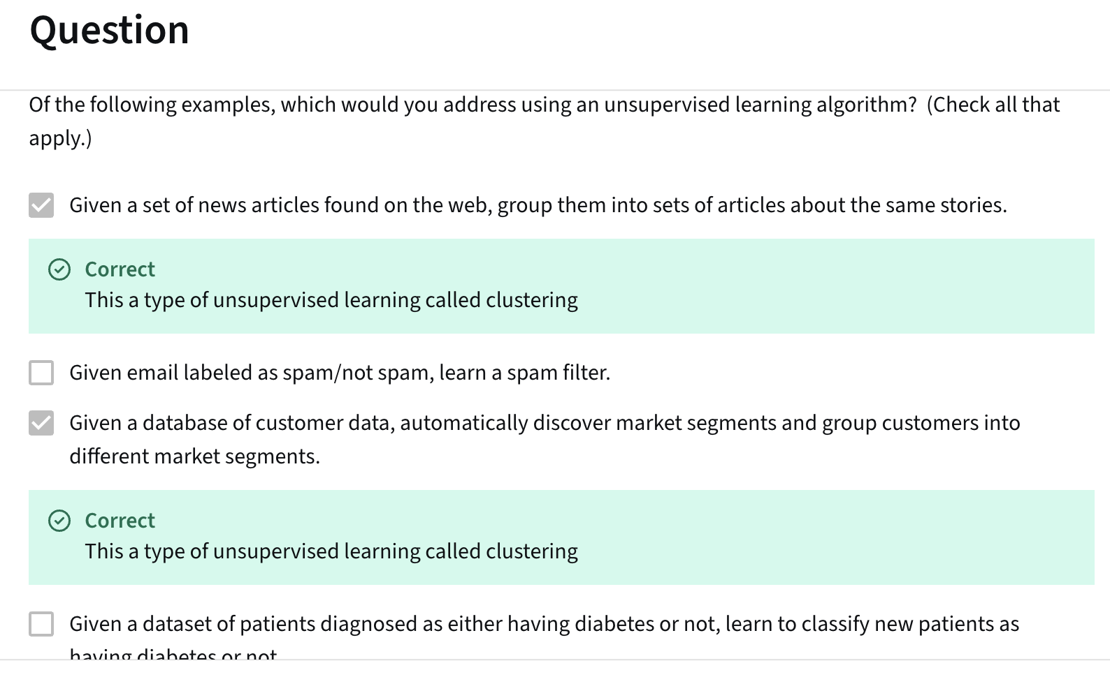

### **🧠 Linear Regression**

* It’s a **supervised learning** algorithm used for **regression tasks**, where the goal is to predict a continuous value (e.g., price).
* In this example:  
   **Input (x)** = size of the house  
   **Output (y)** = price of the house  
   The function f(x)=wx+bf(x) = wx + bf(x)=wx+b estimates price from size.

### **📘 Terminology Explained**

| **Term** | **Meaning** |
| --- | --- |
| **Training Set** | Collection of data with inputs (**features** like size) and outputs (**targets** like price). |
| **Learning Algorithm** | The method (e.g., gradient descent) that learns the function fff from data. |
| **x** | Input feature (e.g., house size). |
| **f(x)** | The function learned (also called the **model** or **hypothesis**, though "hypothesis" is crossed out in image). |
| **ŷ (y-hat)** | The prediction made by the model (i.e., estimated price). |
| **y** | Actual target value (i.e., real price of the house). |

### **✨ Model Representation**

* **Linear function**:  
   fw,b(x)=wx+bf_{w,b}(x) = wx + bfw,b​(x)=wx+b  
   where:  
  + www = weight (slope),
  + bbb = bias (intercept),
  + xxx = input feature (house size),
  + f(x)f(x)f(x) = output prediction (house price).

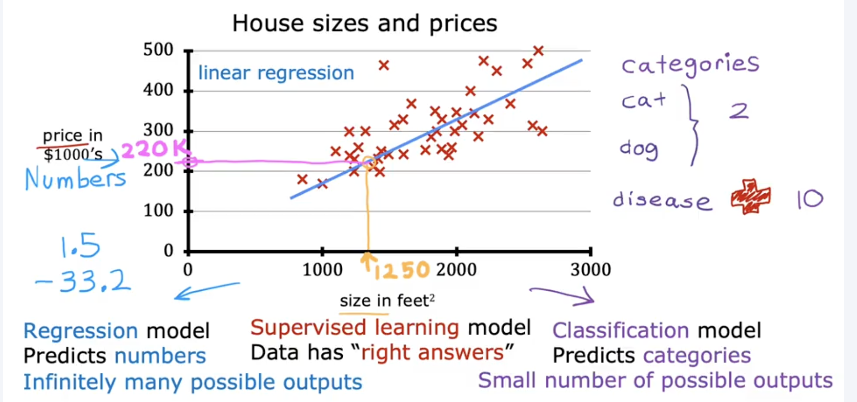

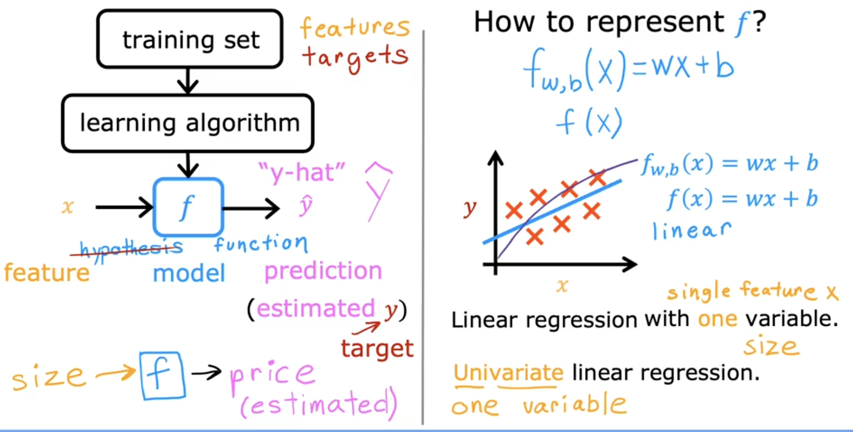

### **🔶 Key Points from the Image**

* **Univariate Linear Regression**: Only **one input variable** (house size).
* **Supervised Learning**: Because we learn from labeled data (x, y).
* Graph shows red X’s as real data points and a blue/purple line as the predicted function.

### **🎯 What is a Cost Function?**

We want our model to **predict values close to real values**.

So we define a **Cost Function** (also called **Loss Function**) to measure **how wrong the predictions are**.

The goal is:

**Find w and b that make our predictions close to the actual data**

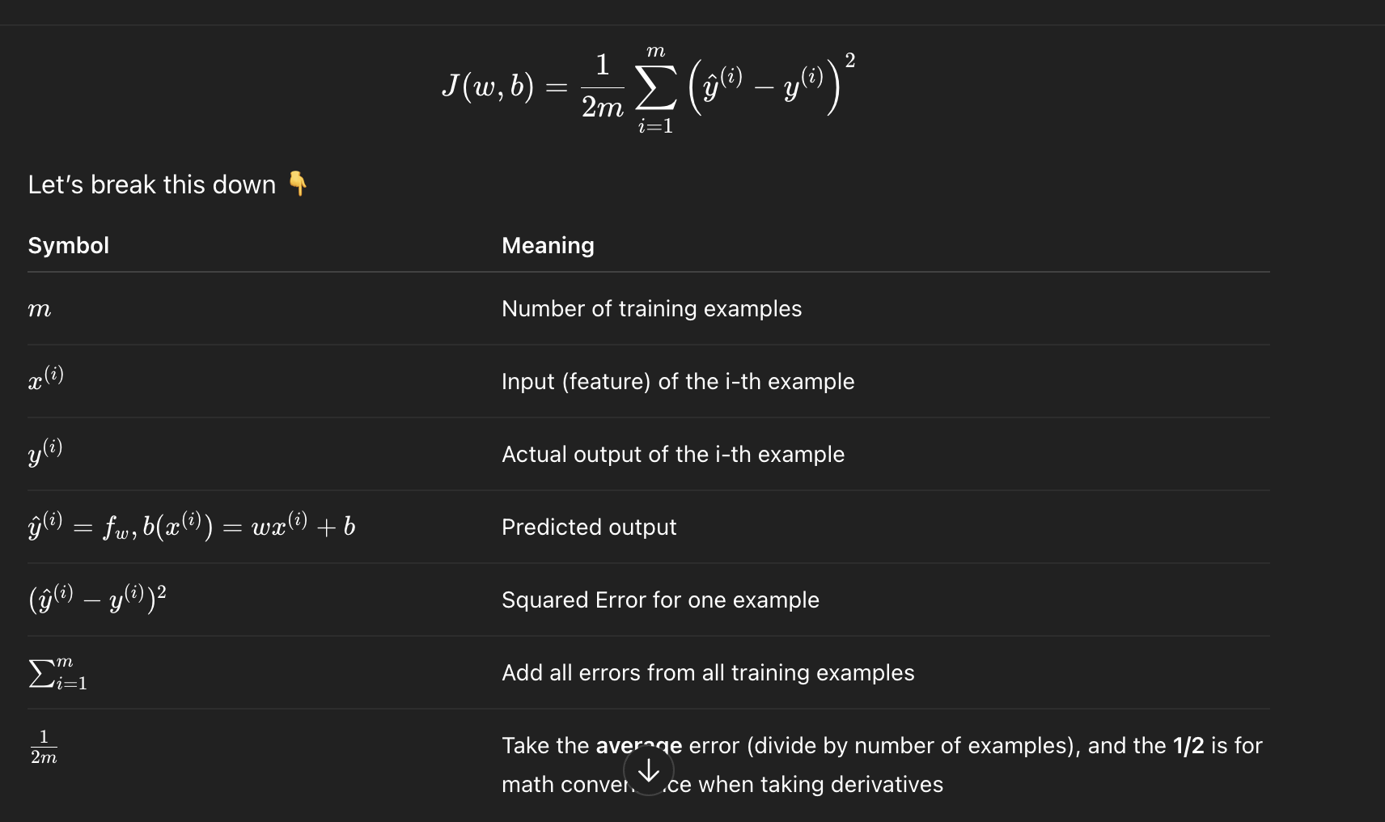

### **📌 What does this function actually do?**

**It calculates the average squared difference between predicted and actual outputs.**

**Smaller cost ⇒ better model.**

### **🎯 GOAL:**

**Find the values of w and b that make the cost function J(w, b) as small as possible.**

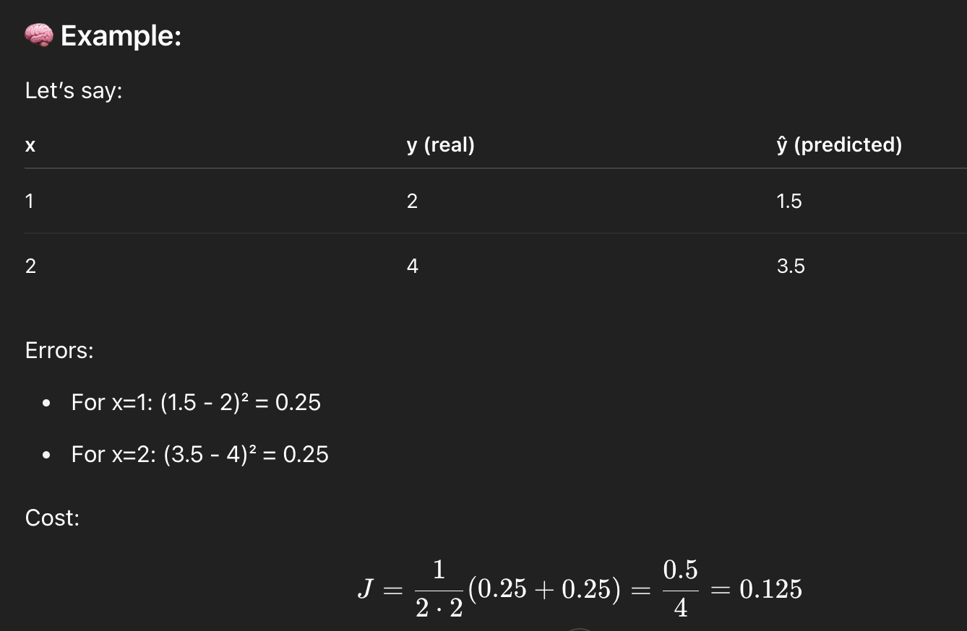

### **V1:- 📘 Linear Regression: Introduction to the Cost Function**

## **🔹 Objective of Linear Regression**

* Given a **training set** with:  
  + Input feature: x
  + Output target: y
* The model we use:  
   fw,b(x)=w⋅x+b
  + w: weight (slope of the line)
  + b: bias (y-intercept)

## **🔹 Terminology**

| **Term** | **Meaning** |
| --- | --- |
| **Model parameters** | The variables w and b that can be adjusted during training |
| **Weights / Coefficients** | Alternate names for model parameters |

## **🔹 What w and b Do to the Line**

* 📏 **Different values of w and b = different lines**
* Example 1:  
  + w = 0, b = 1.5 → flat horizontal line at y = 1.5
  + f(x) = 0·x + 1.5 = 1.5
* Example 2:  
  + w = 0.5, b = 0 → line through origin with slope 0.5
  + f(x) = 0.5·x
* Example 3:  
  + w = 0.5, b = 1 → slanted line starting from y = 1
  + f(x) = 0.5·x + 1

### **✨ Intuition:**

* w controls the **slope** of the line
* b is the **y-intercept** (where the line crosses the y-axis)

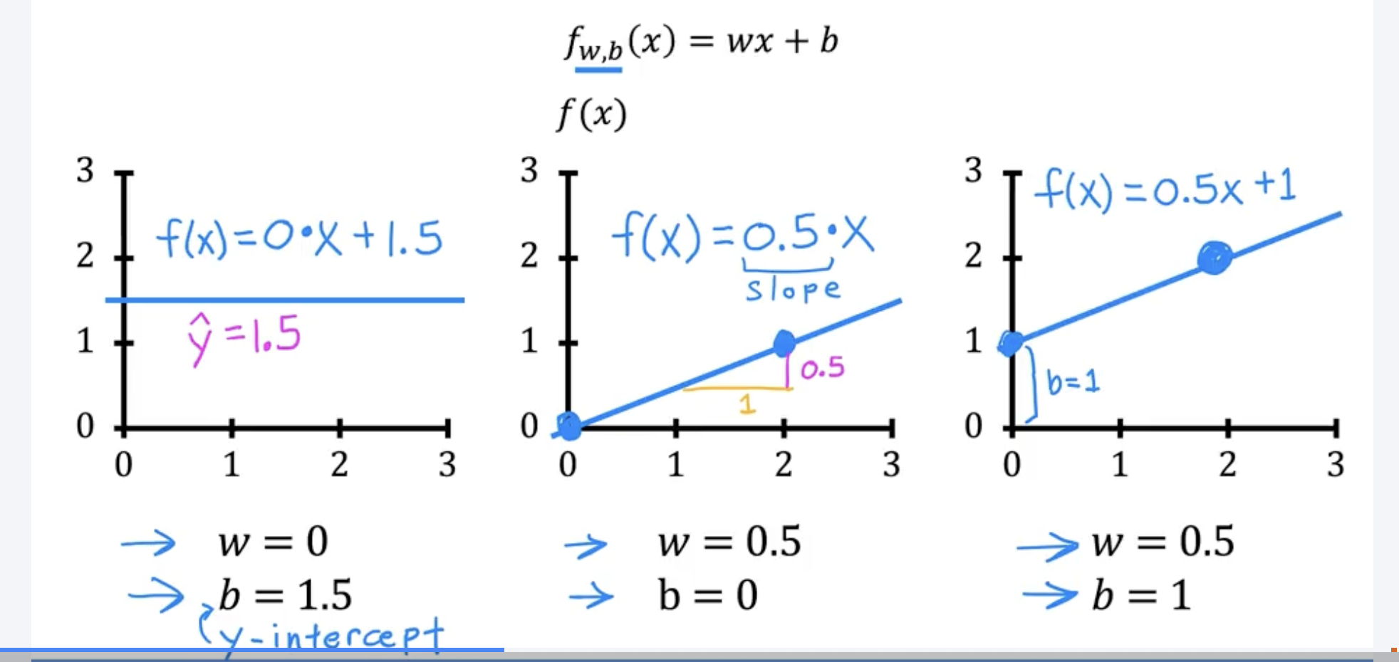

## **🔹 Training Set Example**

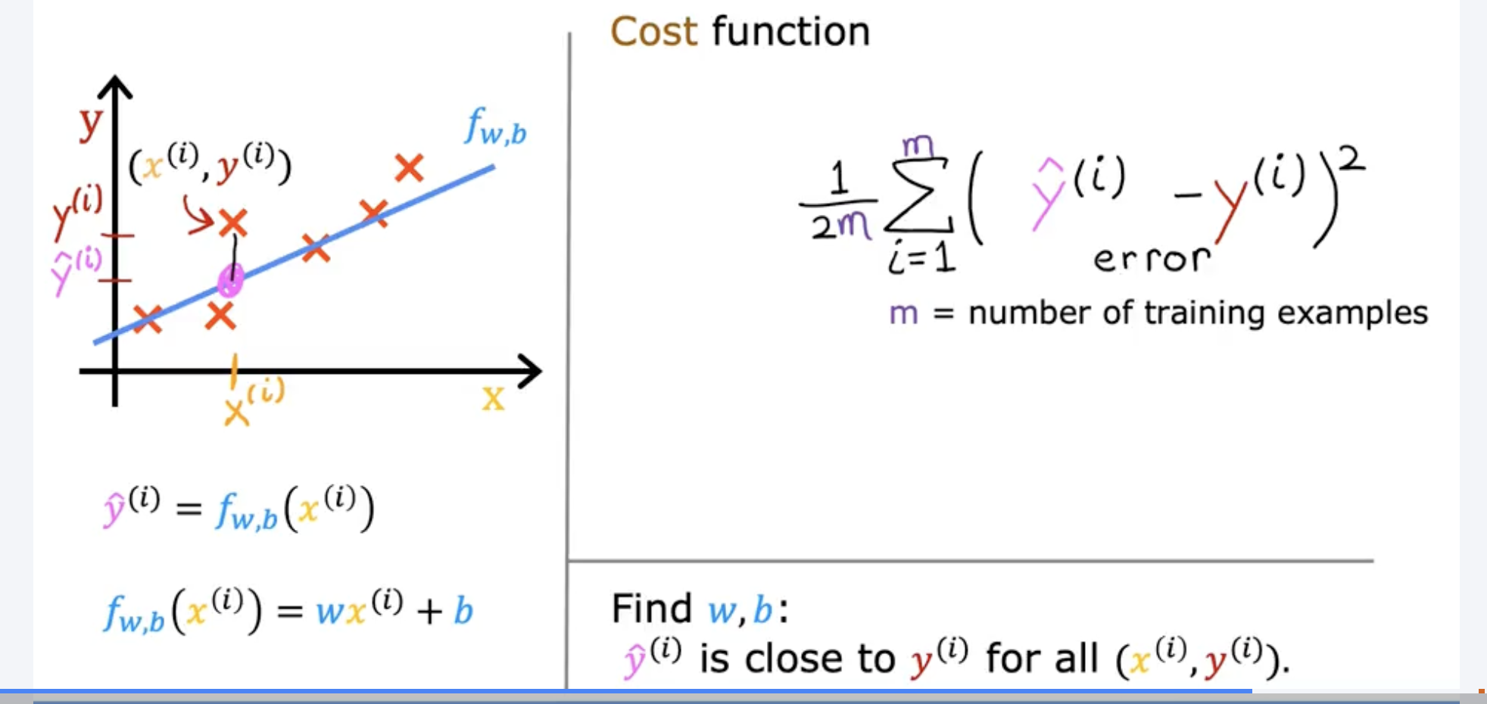

**What’s Happening?**

You see:

* A blue line (f(x) = wx + b) – our **predicted model**
* Red Xs – the **actual training data**
* Purple points – the **predicted values ŷ**
* Arrows – showing **how far off the prediction is** from the real value

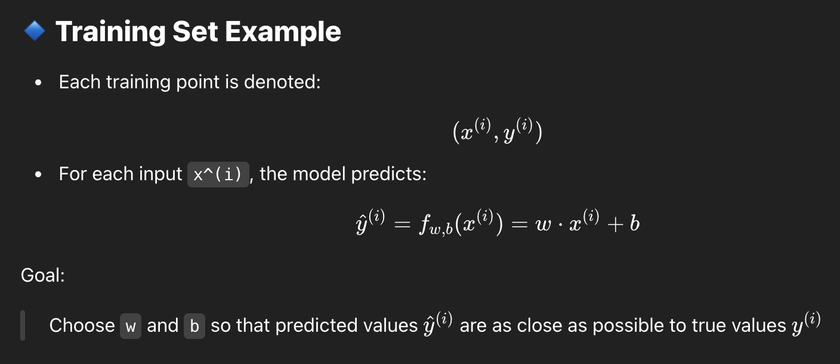

## **🔹 Constructing the Cost Function**

### **❓ Why Cost Function?**

To measure **how well our model fits** the training data.

### **🔸 Step-by-Step:**

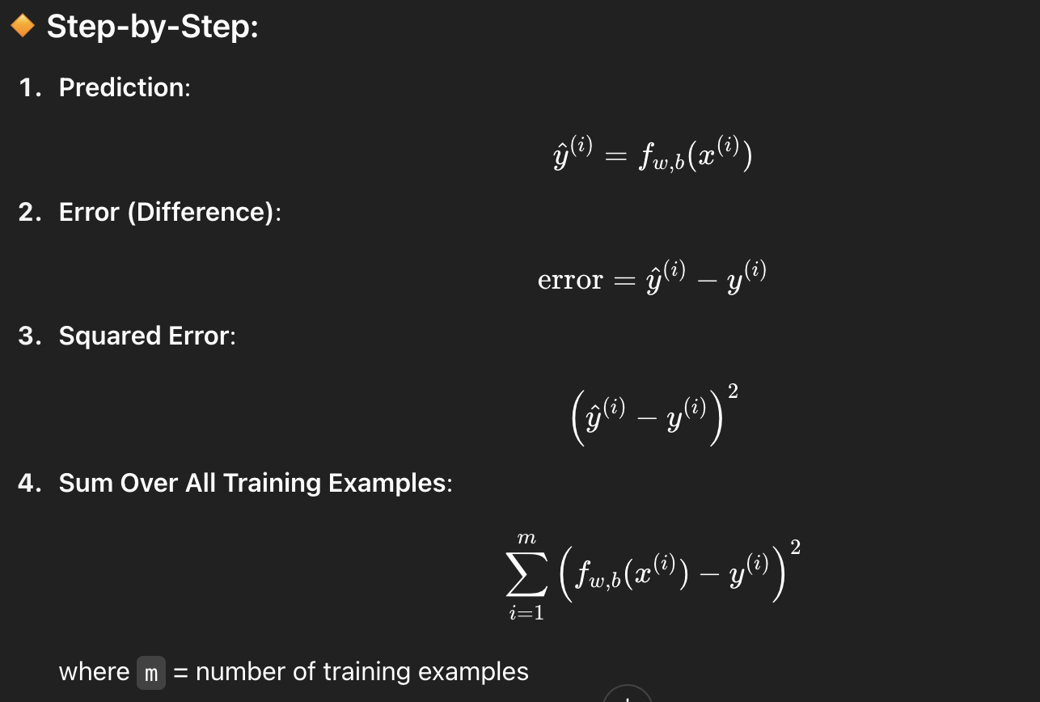

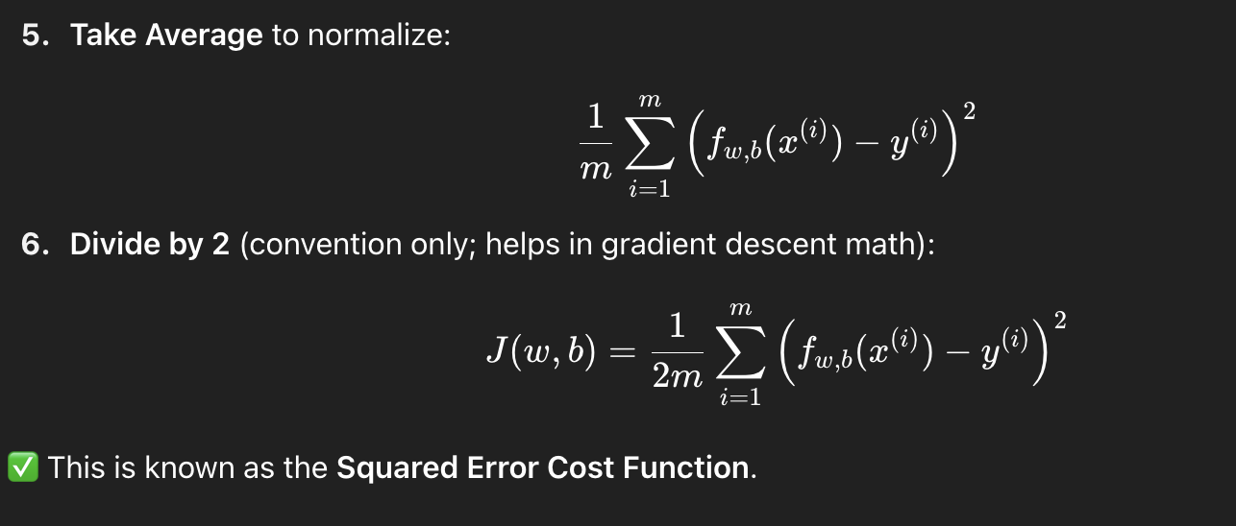

## **🔹 Purpose of the Cost Function**

It tells us:

"How far off are our model's predictions from the true target values?"

* If **J(w, b)** is large → predictions are bad
* If **J(w, b)** is small → model fits data well

## **🎯 Final Goal**

**Find the best values of w and b that minimize the cost function J(w, b)**

### **V2:- 📘 Understanding the Cost Function in Linear Regression**

## **🔷 Objective**

We want to:

**Find the best w and b such that the line fits the training data well.**

To measure “fit,” we use the **cost function**.

## **🔷 Cost Function Definition**

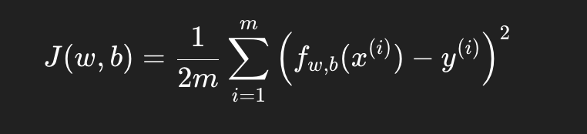

Where:

* m = number of training examples
* x(i) = input
* y(i) = actual output
* f(x(i)) = predicted output

### **🧠 Meaning:**

The cost function **J(w, b)** computes the average squared difference between predicted and actual values.

## **🔷 5. Intuition with Graphs**

We plot **two graphs side-by-side**:

* **Left:** Prediction line f_w(x)
* **Right:** Cost function curve J(w)

### **🧪 Example Dataset:**

Training set:  
 (1,1), (2,2), (3,3)

### **📈 How Cost Changes with Different w**

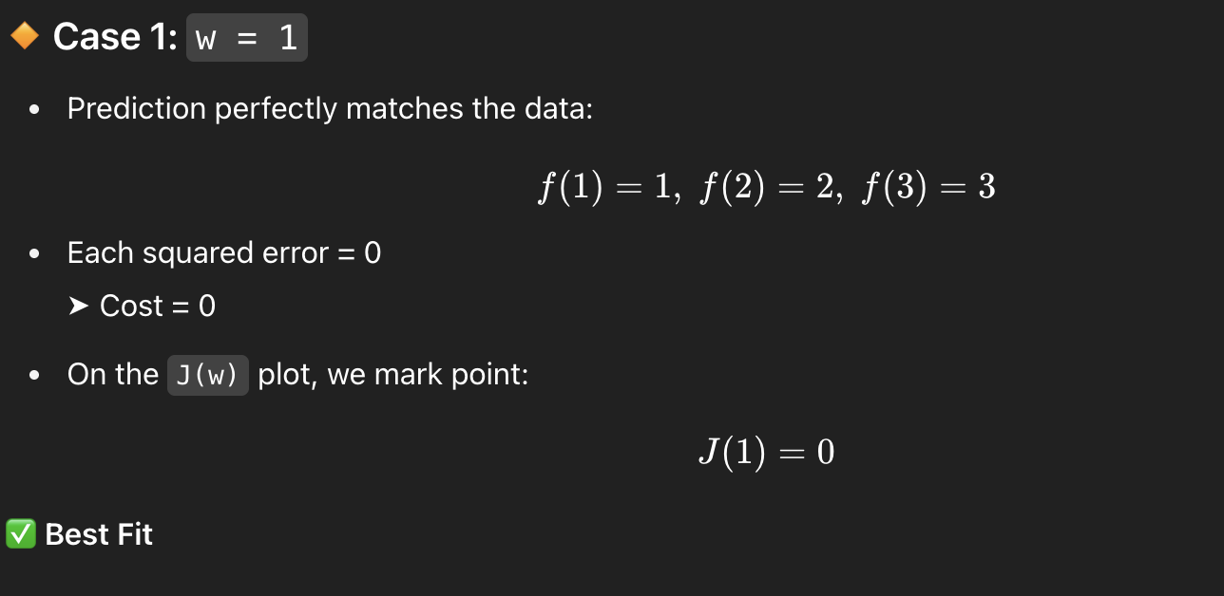

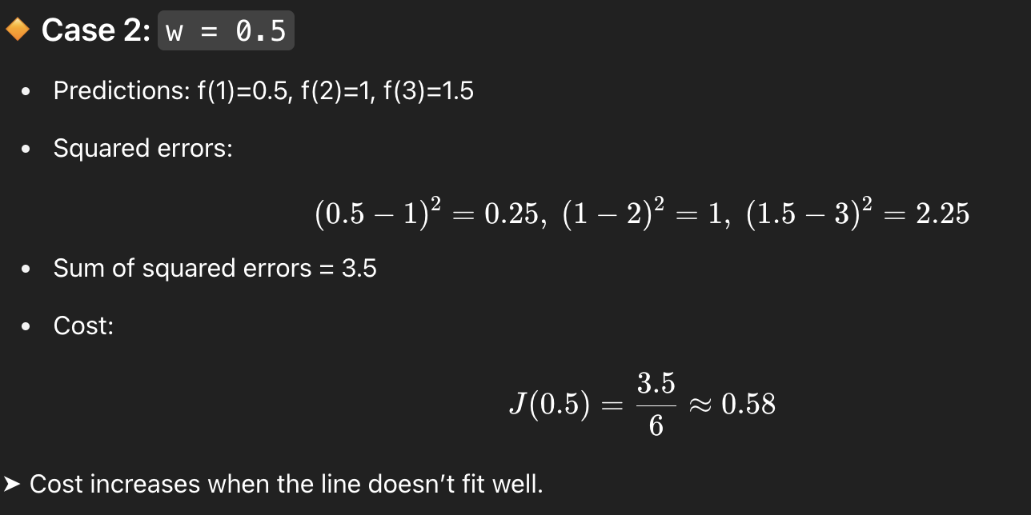

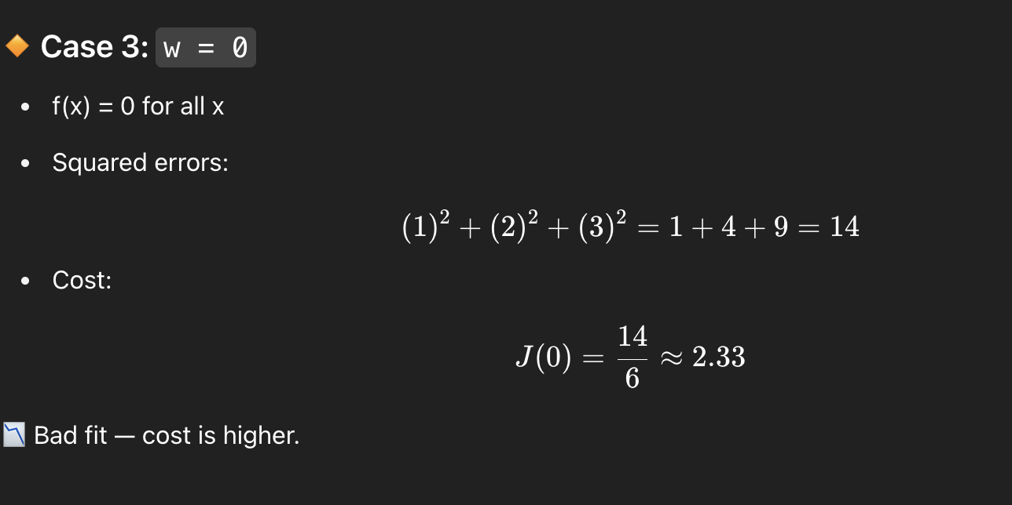

### **🔸 Case 4: w = -0.5**

* Downward-sloping line
* Even worse fit → cost around **5.25**

## **🔷 6. Big Picture**

* Each value of w defines a different prediction line.
* Each line gives a different **cost**, so it becomes a **point** on the J(w) curve.
* If you **plot all values of w**, you get the **cost function curve**.

## **🎯 Conclusion**

* The **goal of training** is to **find the value of w (and b) that gives the smallest cost**.
* In this example, w = 1 gives the lowest cost.
* Linear Regression works by **minimizing the cost function** using algorithms like gradient descent.

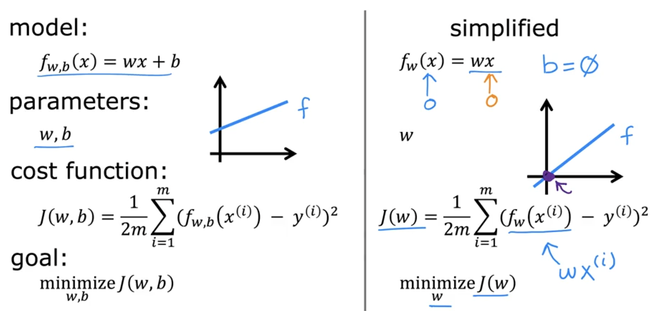

## **🔷 LEFT SIDE — Full Model**

### **🔹 Model**

**fw,b(x)=wx+b**

* **This is your linear regression equation**
* **It means: Predict output using slope w and intercept b**

### **🔹 Parameters**

**w,b**

**These are the two things you control while training:**

* **w = weight (slope)**
* **b = bias (intercept)**

### **🔹 Cost Function**

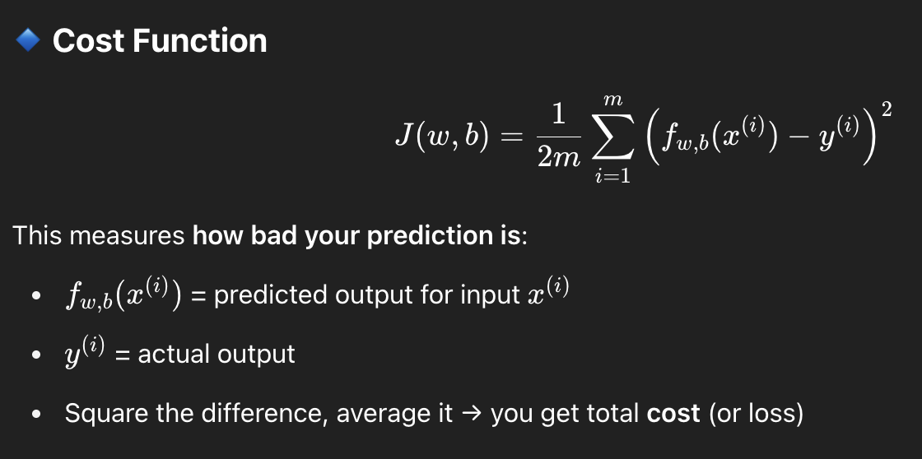

### 

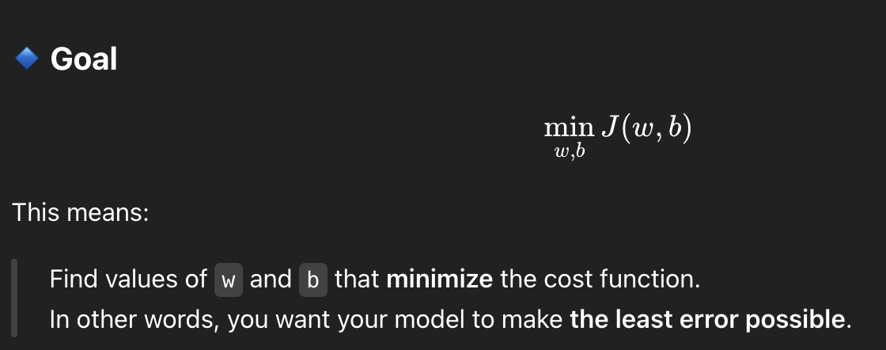

## **🔷 RIGHT SIDE — Simplified Case**

**In this special case:**

**Assume no intercept (i.e., b=0b = 0b=0)**

### **🔹 Simplified Model**

**fw(x)=wx**

* **Only w matters now**
* **Line always passes through origin (0, 0)**

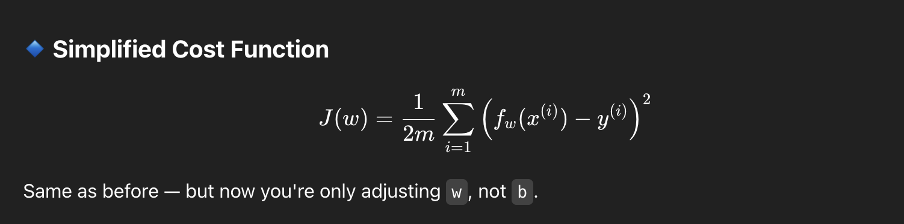

### **🔹 Goal**

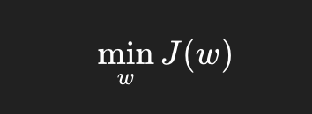

**Now you're just finding the best slope w that fits your data when the line passes through the origin.**

### **V3:- 📘 Visualizing the Cost Function J(w,b)J(w, b)J(w,b) in Linear Regression**

## **🔹 Recap: The Linear Model and Objective**

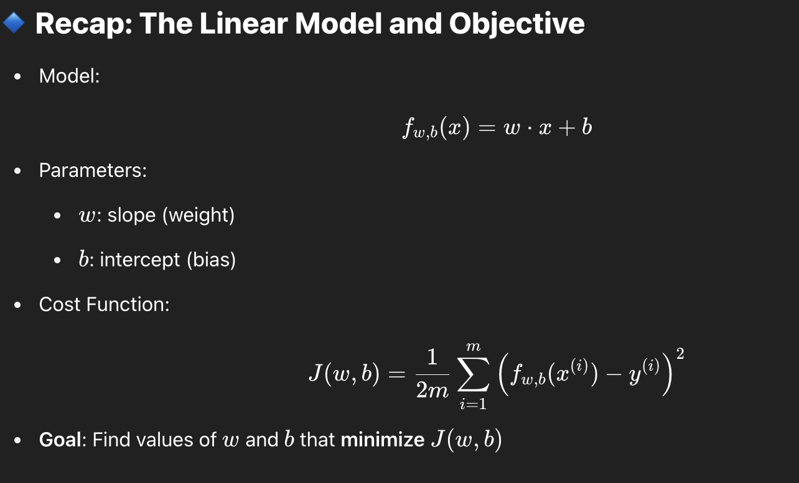

## **🔹 From 1D to 2D Cost Function Visualization**

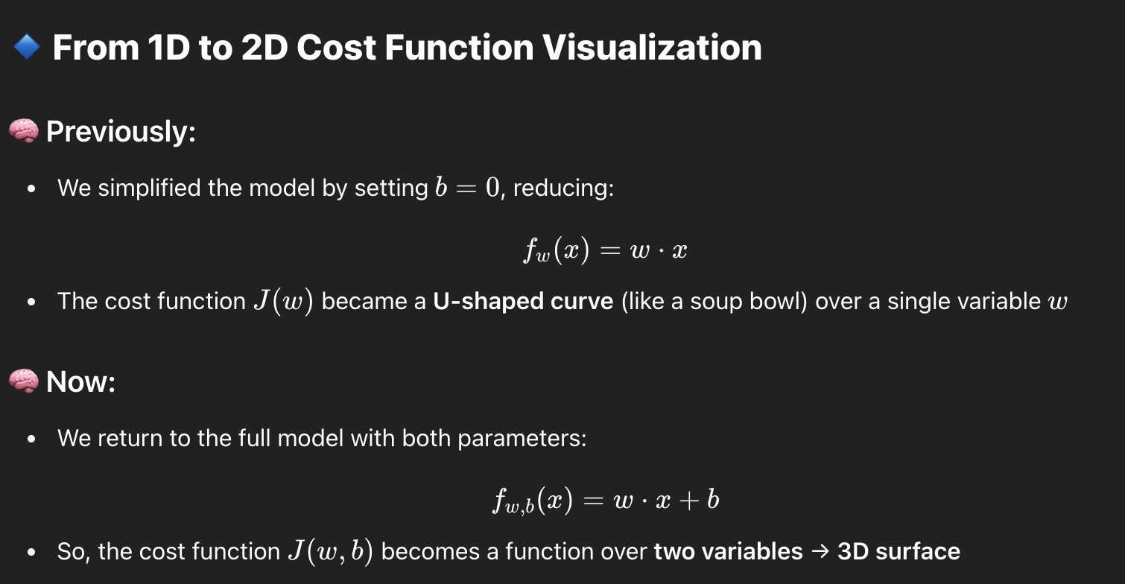

## **🔹 3D Surface Visualization of J(w,b)J(w, b)J(w,b)**

* Imagine a **soup bowl** or a **curved dinner plate** in 3D space
* Axes:  
  + w: horizontal axis 1
  + b: horizontal axis 2
  + J(w,b): vertical height (cost value)

🎯 Each point on this surface represents a specific combination of w and b, and its corresponding cost

Example:

* w=−10, b=−15 → height of surface = J(−10,−15)

## **🔹 Contour Plot: Flattening the Bowl**

### **What is a Contour Plot?**

* A **2D top-down view** of the 3D cost function
* Like slicing the soup bowl **horizontally** and plotting the shape of each height
* Used in:  
  + Geography (e.g. topographical maps)
  + Optimization
  + ML training visualization

### **Features of a Contour Plot:**

| **Feature** | **Meaning** |
| --- | --- |
| **Concentric ovals** | Each oval = points with the **same** cost J(w,b)J(w, b)J(w,b) |
| **Center oval** | Lowest cost (best model fit) |
| **Further from center** | Higher cost (worse fits) |

### **Analogy:**

Imagine a bowl sticking **out of your screen**. If you fly directly above it and look down, you'd see **ellipses** — these are the contour lines.

## **🔹 Visual Insights:**

* Different combinations of www and bbb → different lines f(x)f(x)f(x)
* Each line → corresponds to a **point** in the contour plot
* Poor fit lines (bad w,bw, bw,b) = outer contour circles (higher cost)
* Best fit line (ideal w,bw, bw,b) = center of the contours (minimum cost)

Using these visual tools (3D and contour plots), we understand how linear regression searches for the best parameters that give the **lowest cost** — leading to the best fit line.

### **V4:- 📘 Visualizing the Effect of Parameters www and bbb on Cost Function J(w,b)J(w, b)J(w,b)**

## **🔹 Connecting Line Fit to Cost J(w,b)J(w, b)J(w,b)**

Each point on the **cost function plot** (either 3D surface or 2D contour) corresponds to:

* A specific pair of model parameters (w,b)
* A straight line f(x)=w⋅x+b
* A value of the cost function J(w,b)J(w, b)J(w,b) which tells how well that line fits the training data

## **🔸 Examples of Different (w,b)(w, b)(w,b) Choices and Their Impact**

### **1. 📉 Poor Fit: w=−0.15,b=800**

Line:  
 f(x)=−0.15x+800

* **Effect**:  
  + High intercept (crosses y-axis at 800)
  + Negative slope (slants downwards)
  + Far from most training points
  + ❌ High cost J(w,b)
  + On the contour plot, **far from the center**

### **2. ➖ Flat Line: w=0,b=360**

* Line:  
   f(x)=360
* **Effect**:  
  + Completely horizontal line
  + Ignores the value of xxx
  + Somewhat better than previous, but still ❌ **not a good fit**
  + Still **far from the minimum**, but **closer** than the first

### **3. 📈 Another Poor Fit: Different w,bw, bw,b**

* **Line:**  
   f(x)=wx+b(some random pair)
* **Effect**:  
  + Slightly better or worse than previous depending on pair
  + Still far from optimal
  + Further away from the **minimum of J**

### **4. ✅ Good Fit: Close to Minimum Cost**

* Line:  
   f(x) passes close to most data pointsf(x) \text{ passes close to most data points}f(x) passes close to most data points
* **Effect**:  
  + Small vertical distance (errors) between predictions and actual values
  + Low **sum of squared errors**
  + 📍Point is near the center of smallest contour ellipse
  + **Close to the global minimum** of cost function

### **V1:- 🔻 Gradient Descent: A Beginner-Friendly Explanation**

### **🔸 Why We Need Gradient Descent**

* We have a **cost function** J(w,b)J(w, b)J(w,b), which tells us how good or bad our parameters www and bbb are.
* Our **goal** is to find values of www and bbb that **minimize this cost function** — i.e., make predictions as accurate as possible.

### **🔸 What is Gradient Descent?**

* Gradient descent is an **optimization algorithm** used to find the **minimum** of a function.
* It’s not limited to linear regression — it's used to train deep learning models too!

### **🔸 Key Idea**

Think of gradient descent like:

"Walking downhill on a surface until you reach the bottom (minimum cost)."

Imagine the cost function J(w,b)J(w, b)J(w,b) as a **hilly landscape**:

* You're standing at a point on this hill (initial w,bw, bw,b).
* You look around in all directions.
* You take a **tiny step downhill** in the **steepest direction** (negative gradient).
* Repeat this process until you reach a **valley**, i.e., a **local minimum**.

### **🔸 Algorithm Steps (For Linear Regression)**

1. **Initialize**: Start with any value, usually  
    w=0,b=0w = 0, \quad b = 0w=0,b=0
2. **Repeat** (until convergence):  
   * Compute the gradient (slope) of the cost function at your current location.
   * Update the values of www and bbb by stepping in the opposite direction of the gradient.
   * This is called:  
      w:=w−α⋅∂J∂w,b:=b−α⋅∂J∂bw := w - \alpha \cdot \frac{\partial J}{\partial w}, \quad b := b - \alpha \cdot \frac{\partial J}{\partial b}w:=w−α⋅∂w∂J​,b:=b−α⋅∂b∂J​  
      where α\alphaα is the **learning rate**.

### **🔸 Local vs Global Minimum**

* **Local minimum**: A valley that’s minimum *in its nearby region*, but not the lowest of all.
* **Global minimum**: The **absolute lowest** point of the function.

If the cost function has multiple valleys:

* Depending on where you start (initial w,bw, bw,b), gradient descent may land in **different valleys**.
* It doesn't jump from one valley to another — it *sticks to the one it started descending into*.

### **🔸 Real-world Analogy**

Think of standing on a **golf course**:

* Hills and valleys = cost surface
* You’re blindfolded and can only feel the slope around you
* You take tiny steps downwards toward the lowest point
* Sometimes, you might reach a small valley (local minimum), not the lowest one (global minimum)

### **🔸 Important Properties**

| **Concept** | **Explanation** |
| --- | --- |
| **Gradient** | Direction of steepest increase |
| **Negative Gradient** | Direction of steepest **decrease** (used in descent) |
| **Learning Rate (α)** | Step size — too big = overshoot, too small = slow |

### **V2:- 🔻 Implementing Gradient Descent — Step-by-Step**

### **🔹 1. Objective**

We want to **minimize the cost function**

J(w,b)J(w, b)J(w,b)

by **iteratively updating** the parameters www and bbb.

### **🔹 2. The Update Rule**

The update for each parameter looks like this:

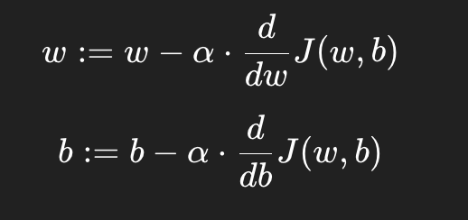

### **🔹 3. Key Terms Explained**

### 

### **🔹 4. Simultaneous Update (Correct Way)**

This is **very important**.

✅ **Correct way (Simultaneous update)**:

temp_w = w - alpha * dj_dw

temp_b = b - alpha * dj_db

w = temp_w

b = temp_b

* dj_dw and dj_db are the partial derivatives.
* We first calculate the updates **for both w and b**, then apply the changes **together**.

❌ **Incorrect way (Non-simultaneous update)**:

temp_w = w - alpha * dj_dw

w = temp_w

temp_b = b - alpha * dj_db # This now uses the updated `w` (bad!)

b = temp_b

This version updates w first, and then updates b using the **already updated** value of w. That’s incorrect for gradient descent.

### **🔹 5. Why Simultaneous Updates Matter?**

Gradient descent imagines you're walking down a hill.  
 If you adjust one leg first and then the other — you could **fall sideways** 🥴

Instead, update both **together** like taking a clean step down the slope. 🧗

### **🔹 6. Convergence**

* We **repeat these updates** for many iterations.
* When w and b stop changing much (i.e., **converge**) — we assume we're at a **minimum**.

### **🔹 7. Code Template (Full Loop)**

Here’s how you’d write this in Python:

# Gradient Descent Algorithm for Linear Regression

# Initialize parameters

w = 0

b = 0

alpha = 0.01 # Learning rate

# Loop for a number of iterations

for i in range(num_iterations):

# Compute derivatives

dj_dw = ... # Use actual formula

dj_db = ... # Use actual formula

# Simultaneous update

temp_w = w - alpha * dj_dw

temp_b = b - alpha * dj_db

w = temp_w

b = temp_b

### **🔹 8. Summary Table**

### **🧠 Mental Model**

Imagine you’re on a hill 🌄 trying to find the lowest point (cost).  
 Gradient descent tells you:

“At your current position, go slightly **left** and **a bit down**, that’s the steepest way to the bottom!”

And you **keep repeating this process** until you're no longer moving much — that’s your local minimum. 🏞️

### **V3:- 🔻 Understanding Gradient Descent Intuitively**

### **🧠 Goal**

We want to **minimize a cost function** J(w)J(w)J(w)  
 (by adjusting the parameter www) so that our model makes better predictions.

## **🔹 Update Rule (For One Parameter)**

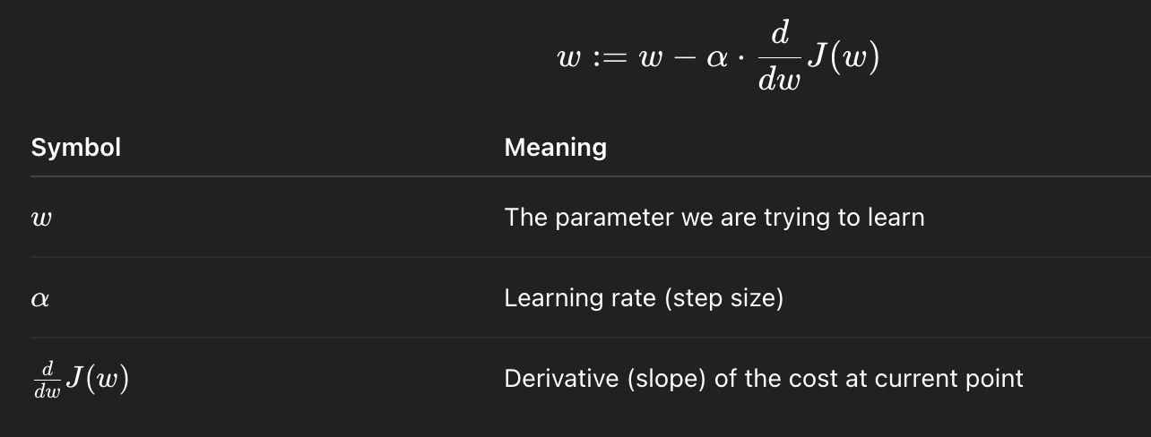

## **🔹 What the Derivative Tells Us**

The **derivative is the slope of the cost function** at your current point www.

* You can **visualize it** by drawing a **tangent line** at the current point on the graph of J(w)J(w)J(w).
* The **slope of that tangent** tells you which way to move to decrease the cost.

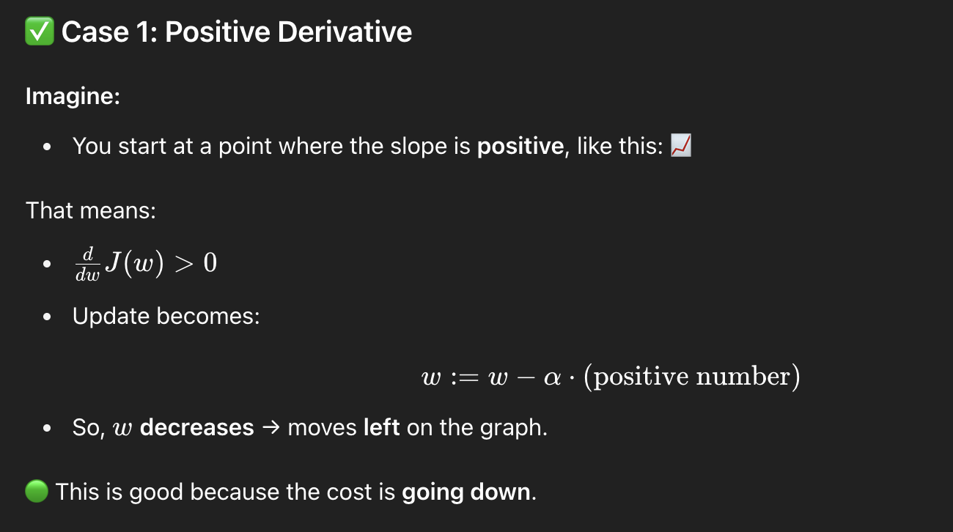

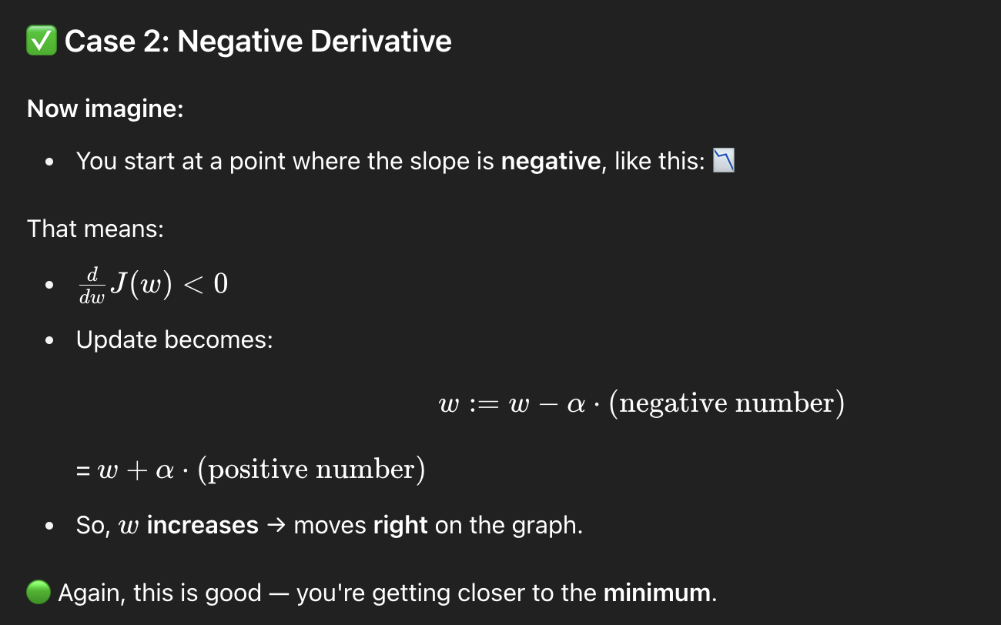

## **🔹 Summary: What the Derivative Does**

| **Derivative** | **What Happens** |
| --- | --- |
| Positive (>0> 0>0) | Move **left** (decrease www) |
| Negative (<0< 0<0) | Move **right** (increase www) |

This is how gradient descent **always moves toward the minimum**.

### **🔍 Tangent Line and Slope Intuition**

When you’re standing on the curve J(w)J(w)J(w), the derivative is like:

"How steep is the ground under your feet?"

Gradient descent says:

“Walk in the **downhill direction**, and take a step based on how steep it is.”

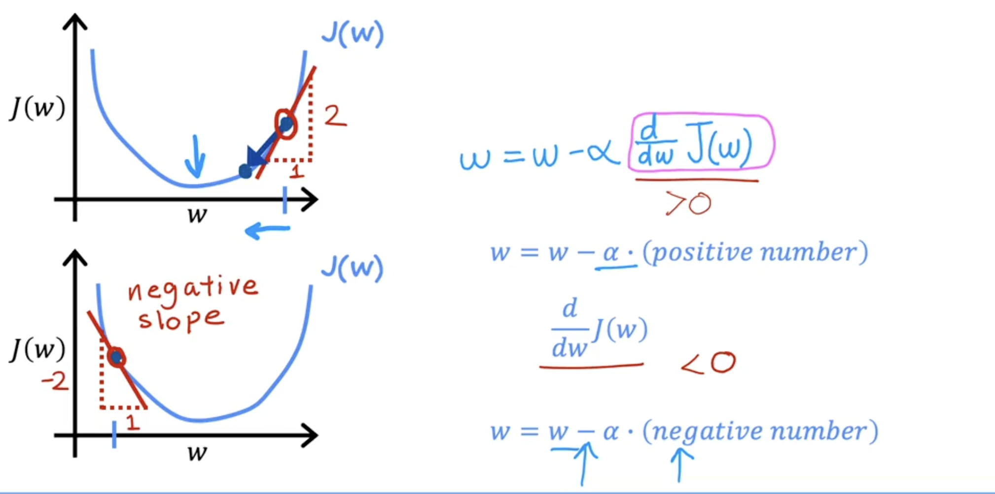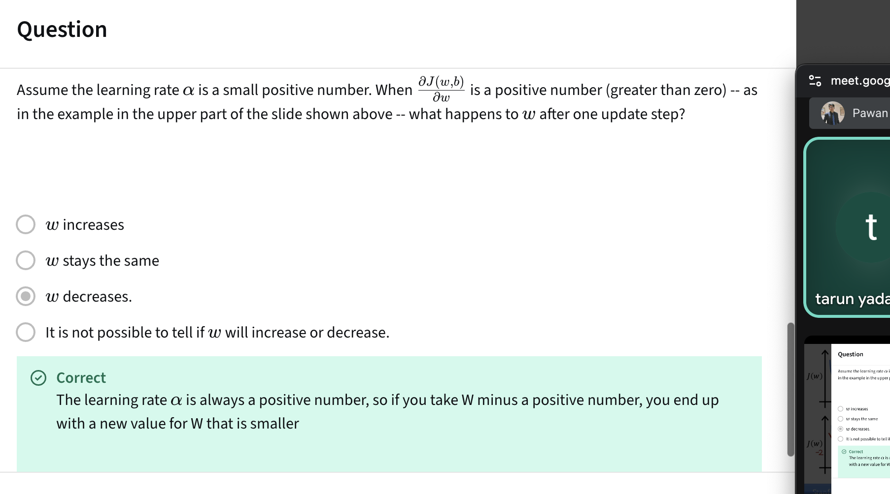

### **V4:- 🔻 Understanding the Learning Rate α\alphaα**

### **🧠 What is the Learning Rate?**

The learning rate α\alphaα controls **how big a step** gradient descent takes in the direction of the **negative gradient (downhill)**.

The update rule:

w:=w−α⋅ddwJ(w)w := w - \alpha \cdot \frac{d}{dw}J(w)w:=w−α⋅dwd​J(w)

## **🔹 What Happens If α is Too Small?**

### **🐢 Behavior:**

* Tiny steps, very slow learning.
* The algorithm still converges, but it may take **a very long time**.
* **Inefficient** training.

### **📉 Visual:**

* Each update moves a **tiny bit** closer to the minimum.
* Thousands of steps may be needed.

### **✅ It works but is painfully slow.**

## **🔹 What Happens If α is Too Large?**

### **🐘 Behavior:**

* Takes **huge steps**, overshoots the minimum.
* May jump back and forth across the minimum.
* Can even **diverge** (cost keeps increasing).

### **🔁 Visual:**

* Instead of going toward the valley bottom, you leap over it repeatedly or shoot off the cliff.

### **❌ It doesn’t work — algorithm becomes unstable.**

### **🔹 What Happens If You're Already at the Minimum?**

### **💡 Insight:**

* At a local minimum, the **slope (derivative)** is **0**.
* So, update becomes:  
   w:=w−α⋅0⇒w:=ww := w - \alpha \cdot 0 \Rightarrow w := ww:=w−α⋅0⇒w:=w
* The parameter **stops changing** — which is exactly what you want.

### **✅ Gradient descent naturally stops at a minimum.**

## **🔹 Why Gradient Descent Takes Smaller Steps Near the Minimum**

As you move closer to a minimum:

* The **derivative** ddwJ(w)\frac{d}{dw}J(w)dwd​J(w) becomes smaller.
* So even with a **fixed** α\alphaα, the **update steps get smaller** automatically.

This creates a **self-adjusting effect**:

* Large updates far from the minimum ✅
* Smaller updates as you get closer ✅
* Eventually, tiny updates near the bottom ✅

## **🔹 Recap: Choosing α\alphaα**

| **Learning Rate α\alphaα** | **Behavior** |
| --- | --- |
| Too small | 🐢 Very slow convergence |
| Just right | ✅ Fast and stable convergence |
| Too large | ❌ Overshooting, instability, divergence |

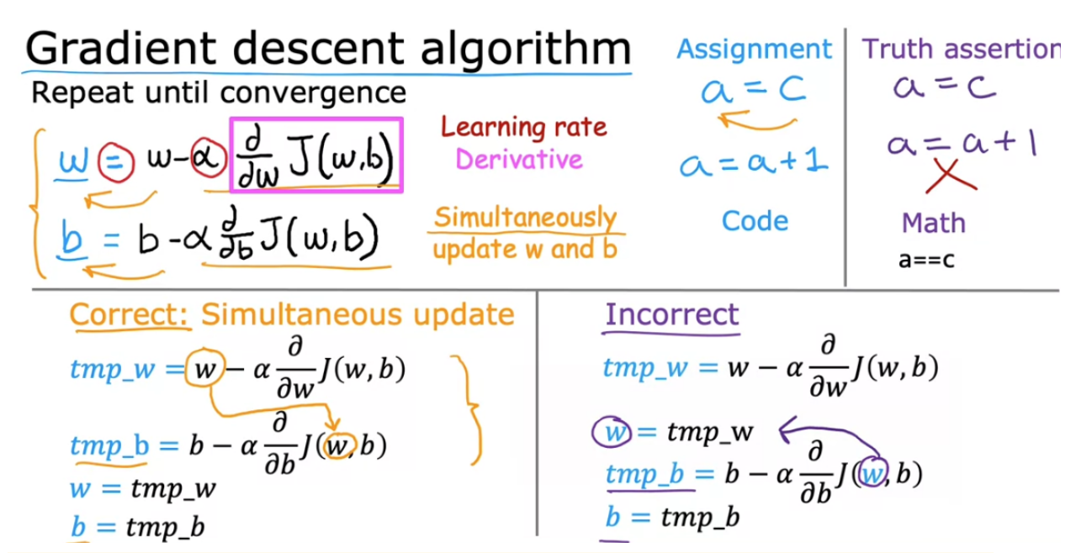

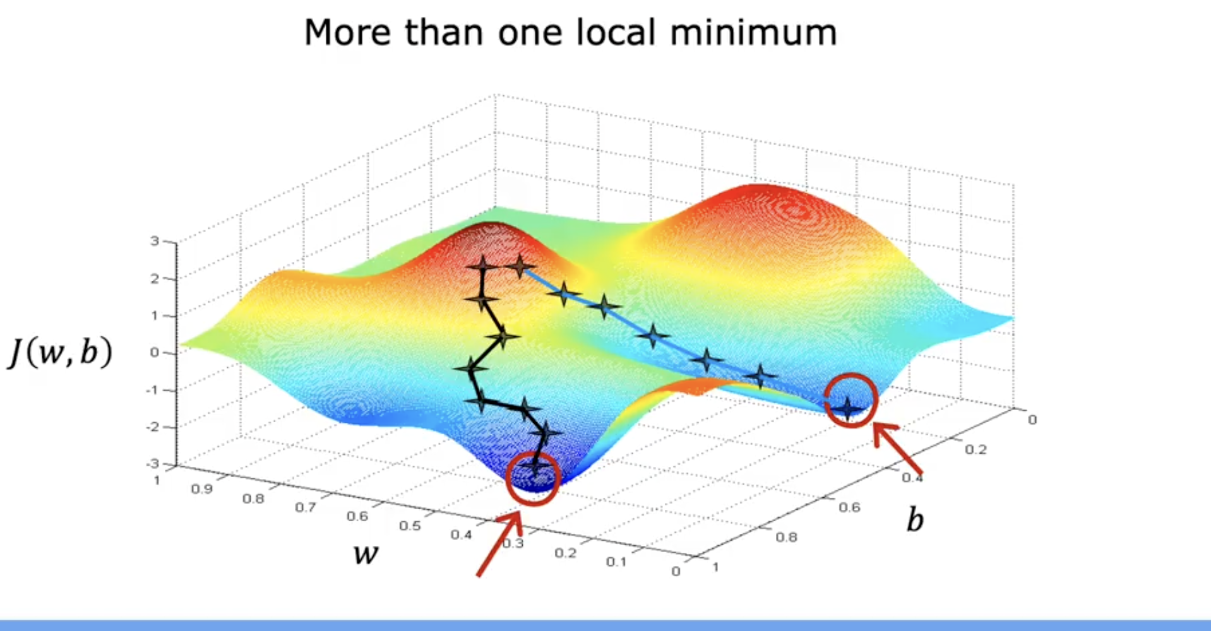

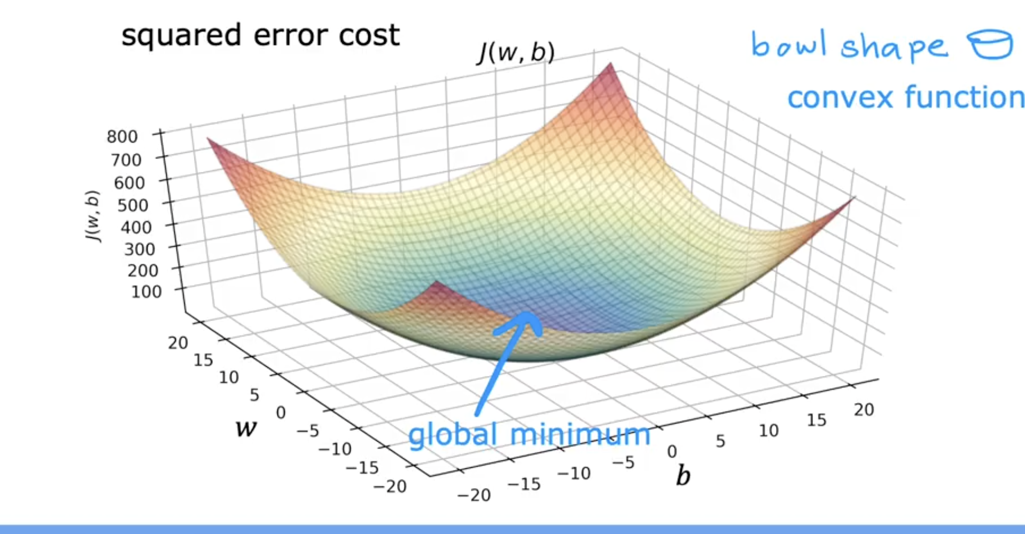

### **✅ Full Gradient Descent for Linear Regression: Step-by-Step Intuition**

### **🔷 1. Model: Linear Regression**

The model predicts output y^(i) using:

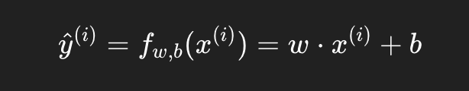

### **🔷 2. Cost Function (Mean Squared Error)**

To measure how far off our predictions are:

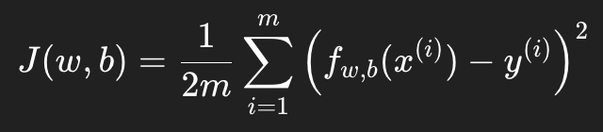

Where:

* mmm: number of training examples
* fw,b(x(i)): predicted value
* y(i): actual target value

We use **1/2m** to simplify the derivative later.

### **🔷 3. Gradient Descent Algorithm**

Our goal: minimize the cost J(w,b)J(w, b)J(w,b)  
 We do this by updating www and bbb **iteratively**:

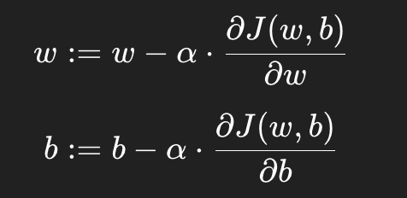

Where:

* α\alphaα: learning rate (controls step size)

### **🔷 4. Derivatives (Gradients)**

Derived from calculus, but here's what you need:

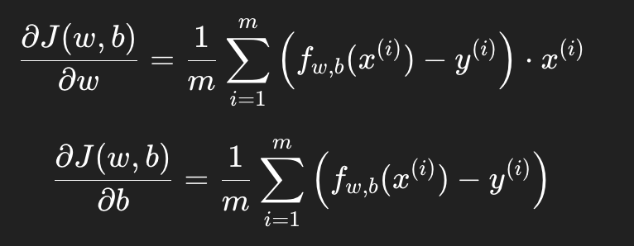

These tell you **how to change** www and bbb to **decrease the cost**.

### **🔷 5. Final Algorithm**

**Repeat until convergence** (i.e. parameters don’t change much):

# Initialize parameters

w = 0

b = 0

# For number of iterations

for i in range(num_iterations):

# Compute predictions

predictions = w * x + b

# Compute errors

errors = predictions - y

# Compute gradients

dj_dw = (1/m) * np.dot(errors, x)

dj_db = (1/m) * np.sum(errors)

# Update parameters

w = w - alpha * dj_dw

b = b - alpha * dj_db

✅ Make sure to do **simultaneous updates** of www and bbb as explained earlier.

### **🔷 6. Why It Works: Convex Cost Function**

* For **linear regression**, the cost function J(w,b)J(w, b)J(w,b) is **convex** (bowl-shaped).
* That means there is **only one global minimum** — no local traps!
* So, **no matter where you start**, gradient descent (with a good learning rate) **will find the optimal solution.**

Convex = Only one lowest point 🥇  
 Gradient descent will always reach it (if α isn't too large)

## **🎯 Summary: You’ve Just Built Your First ML Training Algorithm**

| **Component** | **Meaning** |
| --- | --- |
| **Model** | y^=wx+b |
| **Cost** | Measures how wrong predictions are |
| **Gradient Descent** | Algorithm to improve www, bbb step by step |
| **Derivatives** | Show how much and which way to change parameters |
| **Convexity** | Guarantees convergence to the global minimum |

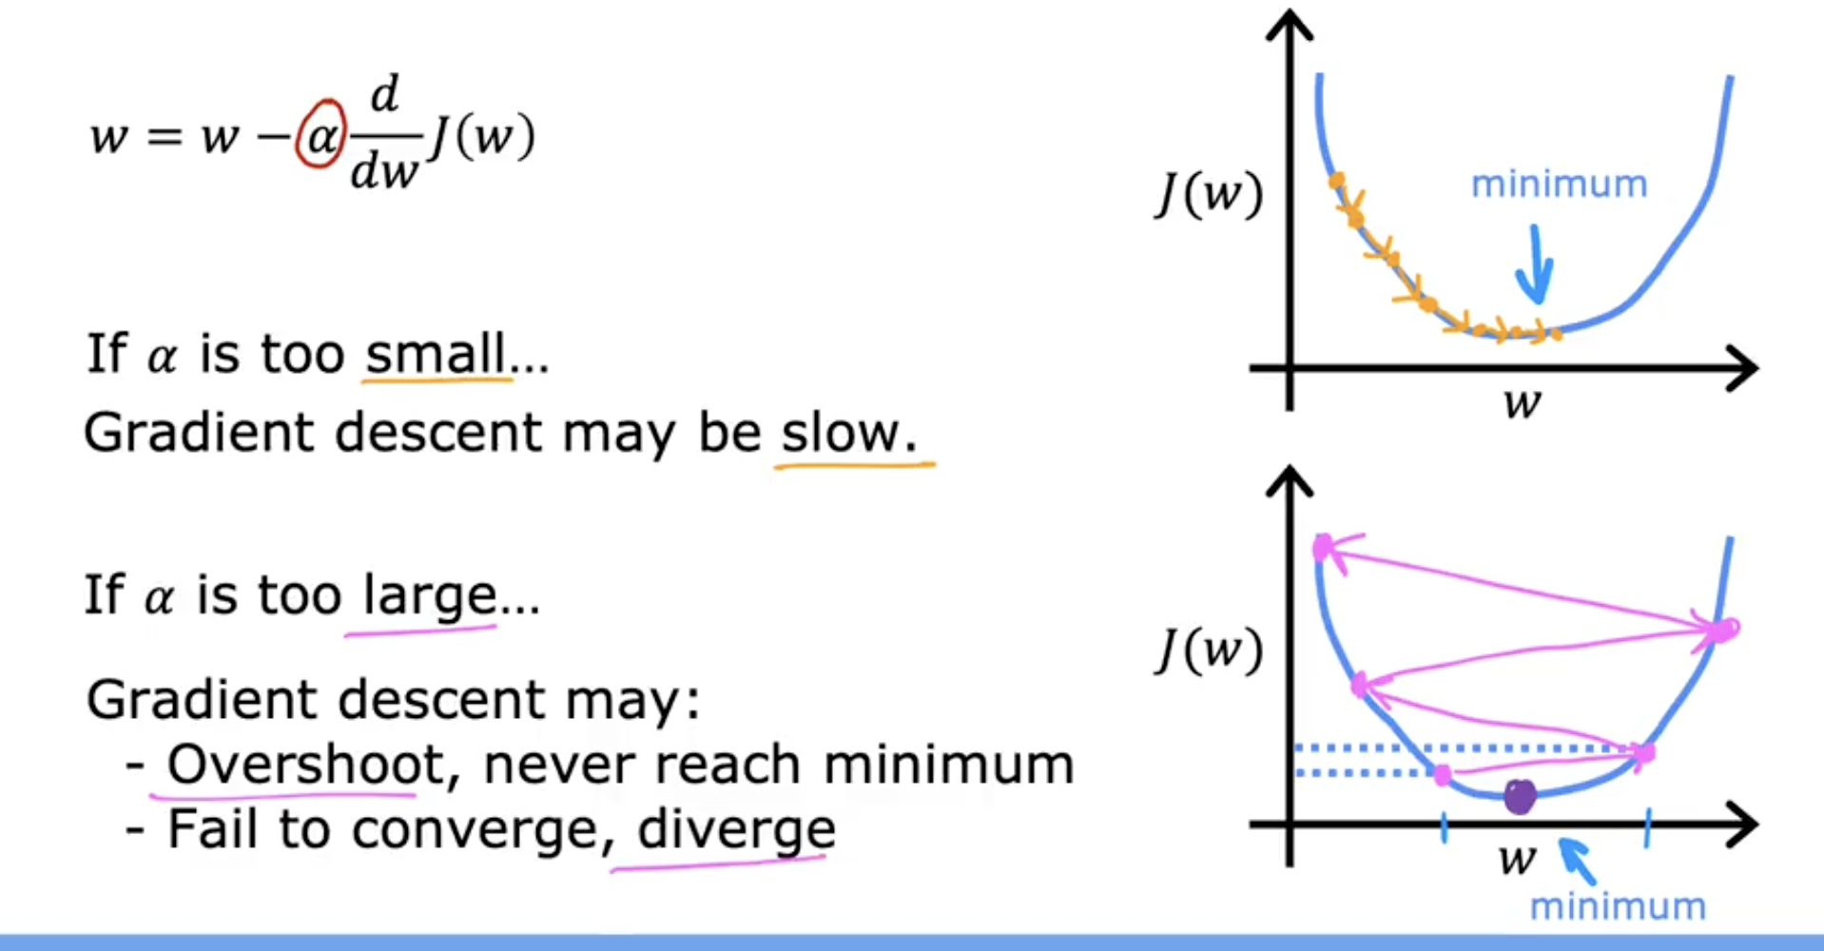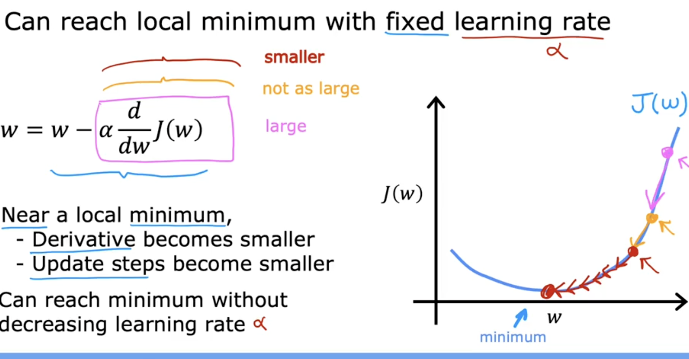

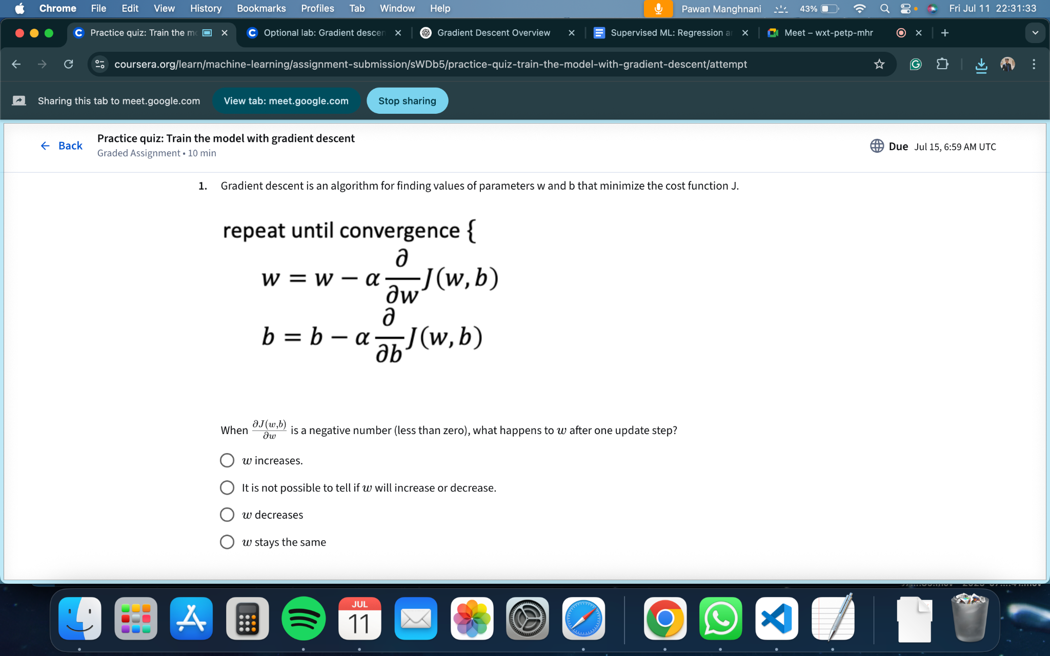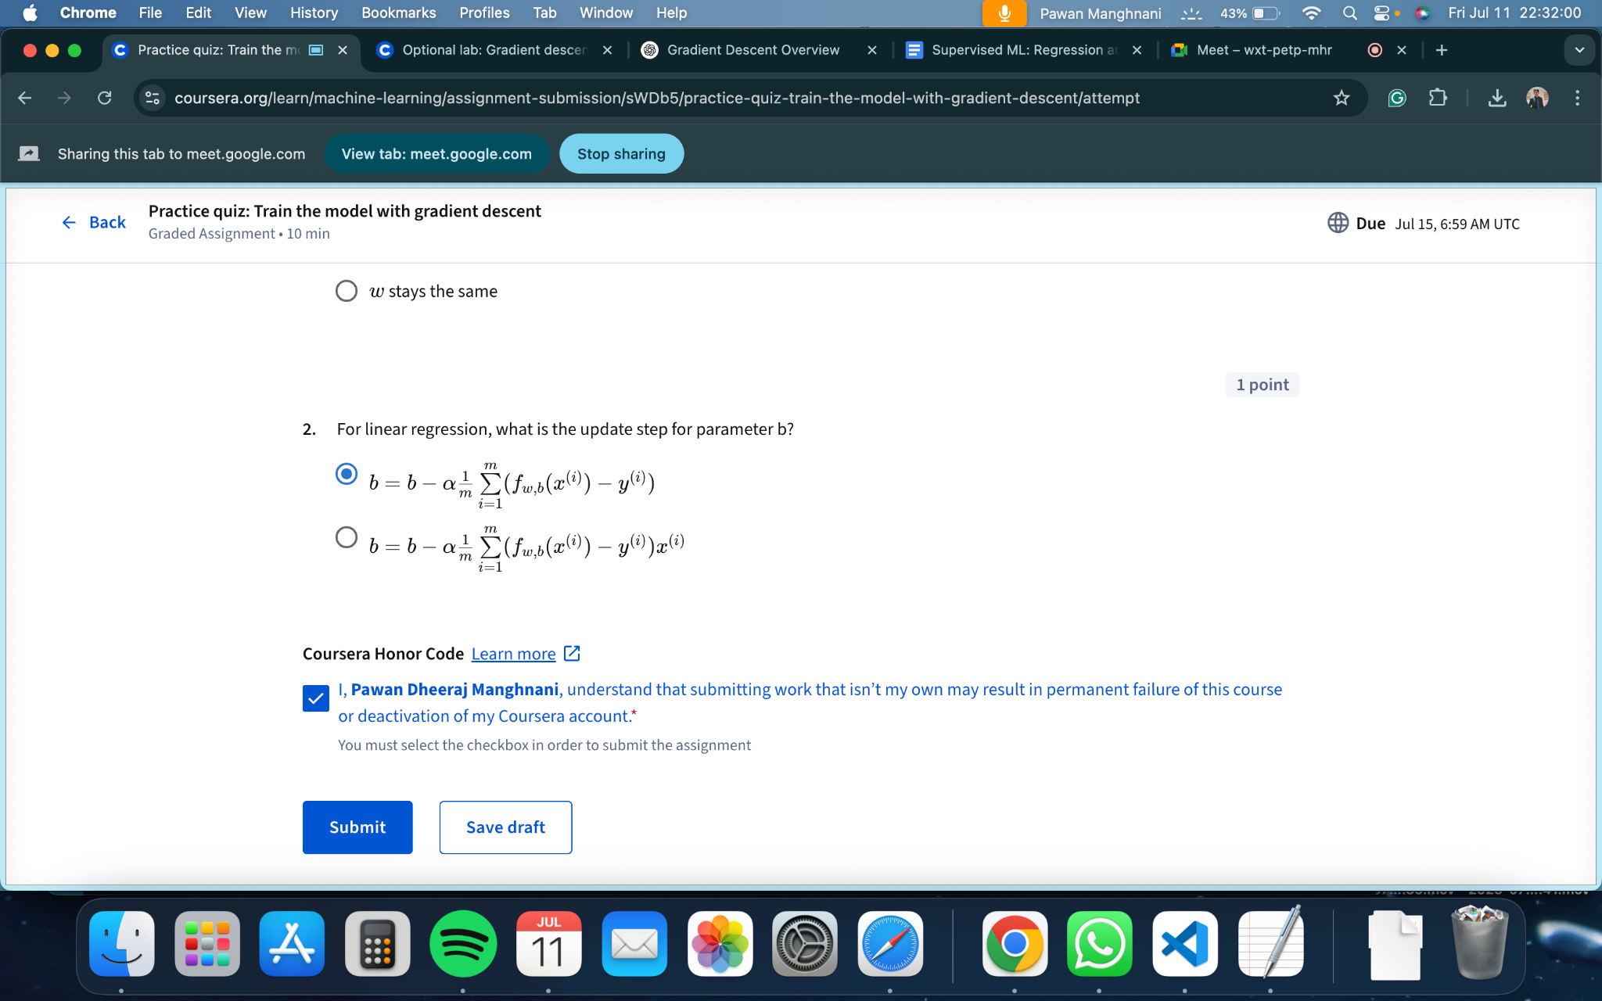

W increases